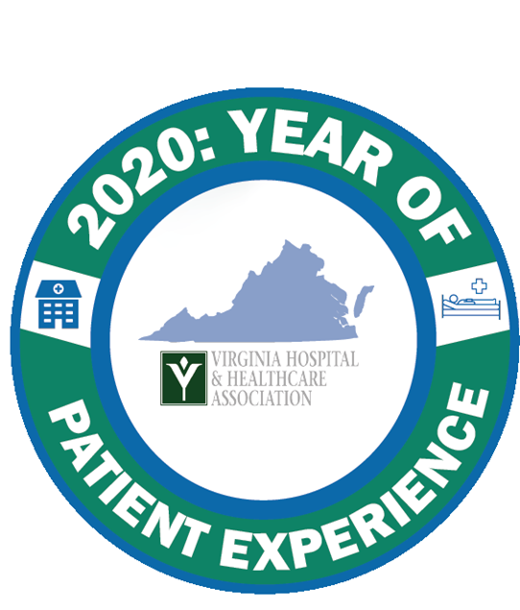
2020: Year of Patient Experience
Executive Summary
February 27, 2020 Webinar
Abraham Segres
Vice President Quality and Safety, Virginia Hospital and Healthcare Association
- The VHHA Board has declared 2020 The Year of Patient Experience. The goals of the initiative are to:
- Identify: Identify, highlight and celebrate efforts by Virginia hospitals and health systems to improve the patient experience of care.
- Integrate: Continue to link and integrate patient experience improvement efforts with broader quality and patient safety improvement efforts.
- Connect: Facilitate connections between Virginia hospitals and health systems and other stakeholders for the purpose of shared learning.
- Improve: Support efforts to improve Virginia hospitals’ individual and aggregate performance on national patient experience measures.

Creating a Culture of Safety and Service
Chris Accashian, CEO, Bon Secours St. Francis Medical Center, Member VHHA Board of Directors
Roberta Azzo, MHA, Operations Program Manager, Bon Secours St. Francis Medical Center
- Embrace the Sisyphusian task of patient experience work. Learn from the failures as well as the achievements.
- Sustaining a culture of safety and service at St. Francis Medical Center involves:
  - Hiring (and keeping) the right people
  - Setting clear expectations and consistently communicating
  - Focusing on key goals and sharing results
  - Holding everyone accountable
  - Reinforcing through reward, recognition and celebration
- The "voice of the patient" kicks off executive management team meetings through a patient comment (positive or negative) from survey responses, letters or leader rounding.
- A 2020 revamp of the Patient and Family Advisory Council involves the Council serving as the voice of the patient for improvement projects and initiatives, empathy training, trauma informed care and call bell responsiveness. 2019 highlights included redesigning inpatient and ED patient care boards and unit GEMBA walks.
- Annual awards for the service pillar recognize units creating an exemplary patient experience.
The "Three Must Haves": Bedside Care Report, Leader Rounding, Purposeful Hourly Rounding
- Since 2016, the hospital has focused on the three must haves.
- AIDET (Acknowledge, Introduce, Duration, Explanation, Thank You) is the communication tool at the heart of all three must haves; it is introduced at new employee orientation and included in annual compliance evaluations for all employees.
Leader Rounding
- Leader rounding was originally conducted on 90% of patients, but only 50% of patients remembered that leaders had rounded. Recent efforts have focused on the quality rather than the quantity.
- There isn't time to round on all patients in the two hours of "sacred time" allocated for rounding. Instead leaders focus on targeted patient populations: new admissions, discharges, and focus patients. Both non-clinical and clinical leaders round, weekdays and weekends.
- In July 2019, a redesigned leader process was rolled out using an electronic platform for easy reporting, unstructured questions designed to promote connections with patients and families, and opportunities to escalate concerns and recognize excellence in real-time.
"A CHAT" Framework
for Leader Rounding

A: AIDET
C: Connect and learn something non-clinical
H: High-five! What are we doing well?
A: ARCC concerns in real time
T: Trends you are noticing
- Leaders are asked to have "A CHAT" with patients. The framework promotes personal connections without scripting. One unit notes the personal information on a board in the patient room (e.g. patient breeds puppies).
- A column for leader rounding on the board in each unit serves as a visual reminder. Unit directors summarize leader results and report at bi-weekly Experience of Care meetings.
Bedside Care Report
- Frontline staff, in partnership with members of the Patient and Family Advisory Committee, developed an educational video for what is an effective bedside care report.
- All new hires are educated on the practice and biannual observation audits reinforce it.
Purposeful Hourly Rounding (PHR)
- The purposeful hourly rounding process has evolved from a quantity focus to a quality focus. It was launched in 2016, but initially focused on the hourly timing. In 2017, a monitoring alert system was implemented to ensure hourly rounds but contributed to alarm fatigue and had little value. In 2018, the hospital streamlined documentation by eliminating the requirement to document PHR in the electronic health record and instead began using the patient care board as the accountability tool.
- An internal data analysis demonstrated that patient perceptions of the quality of rounding rather than the frequency of rounding was associated with improved HCAHPS overall rating scores. In 2019, the hospital "flipped the script" and emphasized the 5 Ps of rounding as a measure of effectiveness.
- The refreshed program is reinforced through education (see below), quarterly audits, and reward and recognition.
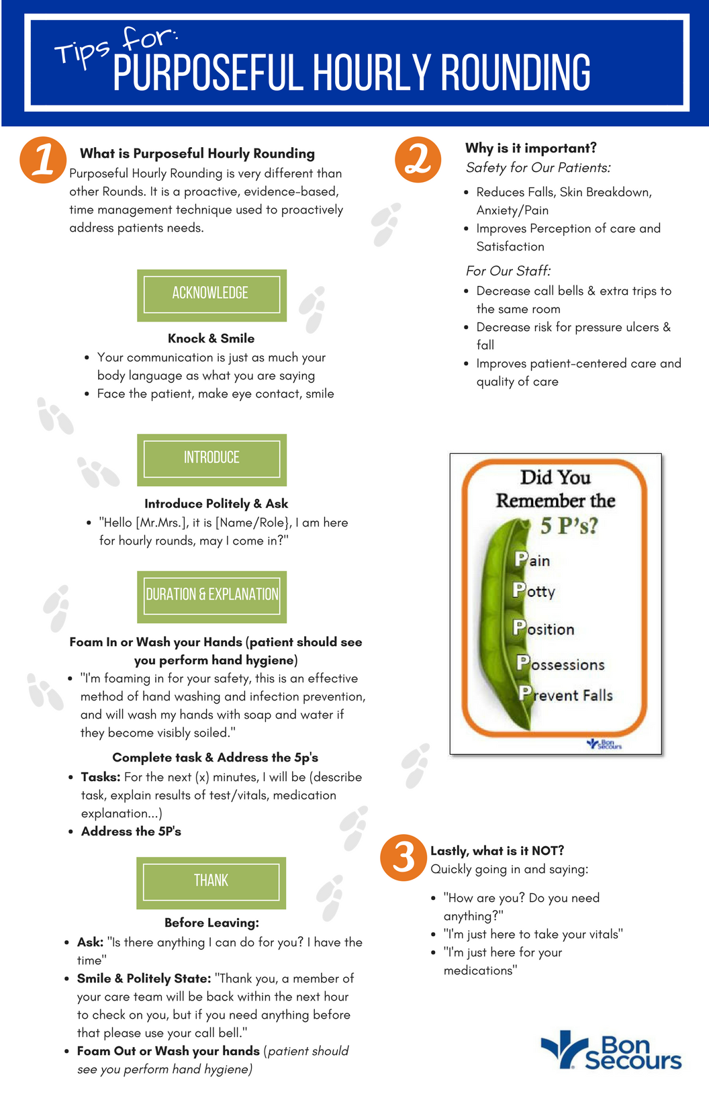
Carrie Brady, VHHA Patient Experience and HCAHPS Advisor
- The Year of Patient Experience is grounded on four foundational elements: leadership, patient and family engagement, staff engagement, and effective use of data. The presentation today illustrates how all of the foundations are important and work together.
- 94% of the webinar participants reported their leaders round on patients, but only half involve both clinical and nonclinical leaders in rounding. Using nonclinical leaders can provide a fresh perspective as well as expand the team available for rounding. Half of the webinar participants reported that they use a structured leader rounding process without specific questions, 31% of participants use specific questions and 17% do not have a specific structure.

Which Leaders Routinely Round? Are Leader Rounding Conversations Structured?

- Hospitals are invited to share their leader rounding questions/process and to partner with VHHA to adapt a patient and family advisory council toolkit to include Virginia-specific examples. Please contact Abraham Segres at asegres@vhha.com to participate.

Next Webinar: March 26, 2020
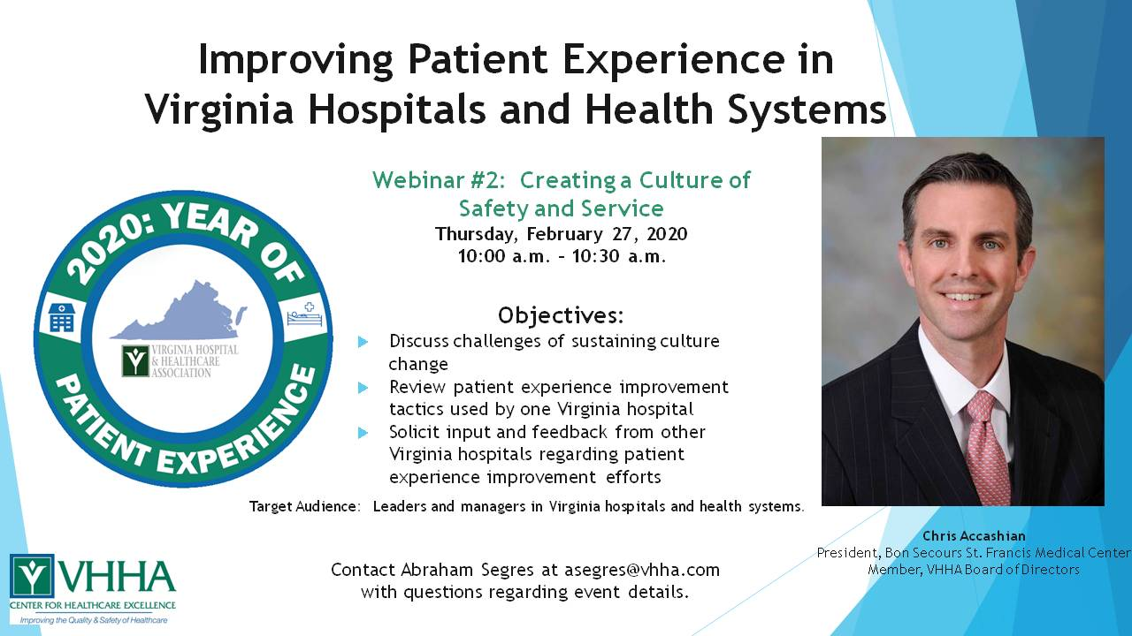
Register using the following link: https://attendee.gotowebinar.com/register/1855983728700908556

